Chapter 8 Disease
extra worksheet 2:Pathogens and antibodies
Science Understanding Science investigation Logical/Mathematical
Antibodies are specific, meaning that each antibody is able to fight only one disease.
Pathogens A to F have invaded the body. Antibodies 1 to 5 are there ready to fight disease.
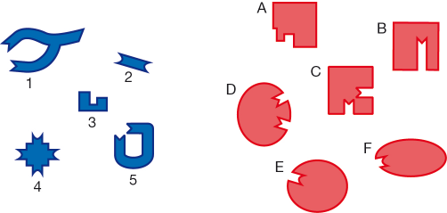

1 Propose which antibodies will fight each of the pathogens.
Pathogen | A | B | C | D | E | F
Antibody
2 Explain how you were able to match up the pathogen and the antibody.

3 a Identify the pathogen that is likely to cause disease.

b Explain why that pathogen could cause disease.

4 Create an antibody that would be able to fight the disease.
5 Explain why the antibody you have created would be able to fight only that disease.

